|  |  |
| --- | --- |
| DATE | 30-10-2023 |
| TEAM ID | A02964A2AF1DAB3845B4FDC5A99BAFE9 |
| PROJECT TITLE | Create Google ad campaign for a brand |

**PROJECT REPORT**

**1.OVERVIEW**

**1.1 INTRODUCTION**

In today's digital age, online advertising has become a vital strategy for businesses aiming to reach their target audience effectively. Google Ads, formerly known as Google AdWords, is a powerful advertising platform that allows businesses to create and manage online campaigns to promote their products or services. With Google Ads, you can reach potential customers precisely when they are searching for the products or services you offer. This introduction will provide you with essential information to kick-start your Google Ads campaign.

**1.2 PURPOSE**

The purpose of Google Ads is to enable businesses to reach a vast online audience, precisely targeting potential customers based on their search queries, interests, and demographics. By creating compelling ads and strategically selecting keywords, businesses can promote their products or services at the exact moment when users are actively seeking related information. Google Ads operates on a pay-per-click model, ensuring cost-effectiveness as advertisers only pay when users engage with their ads. This platform provides measurable results, allowing businesses to analyze campaign performance, optimize strategies, and maximize return on investment. Ultimately, Google Ads empowers businesses to enhance brand visibility, drive website traffic, and increase conversions, leading to business growth and success.

**2.PROBLEM DEFINITION AND DESIGN THINKING**

**2.1 EMPATHY MAP**

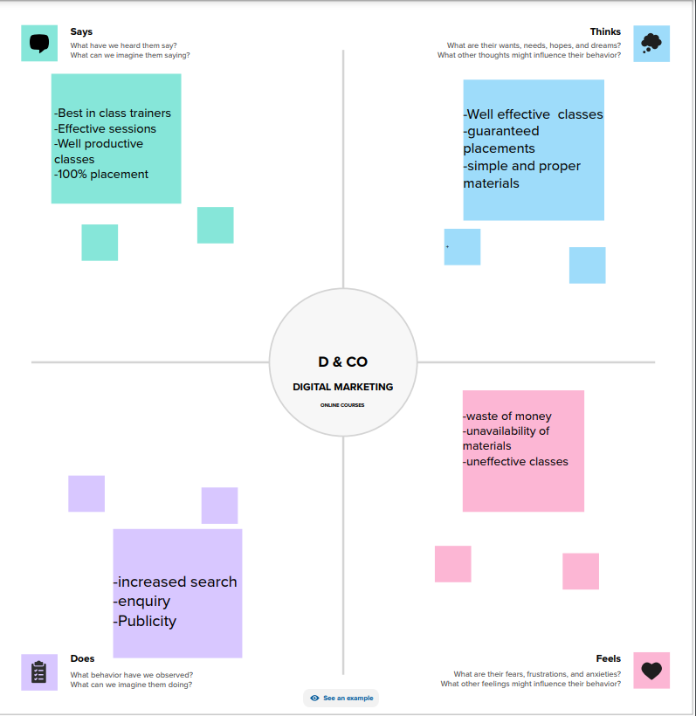

**2.2 BRAINSTORMING AND IDEATION PHASE**

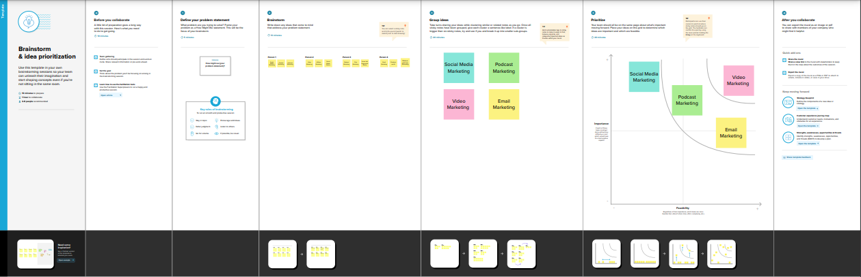

**3.RESULT**

We had successfully created a google ad for dhaanish itech college. By leveraging targeted keywords and compelling ad copy, it drives relevant traffic to the website. This increased visibility often translates into higher sales, leads, or website interactions, boosting revenue and brand recognition.

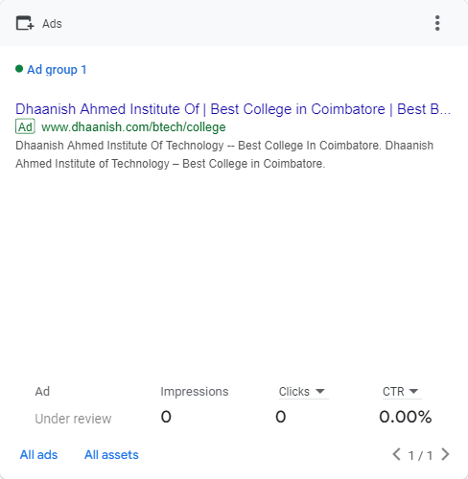

We created the google ad for the brand dhaanish itech using google ads campaign.

**Here is the link of our ad:**

[www.dhaanish.com/btech/college](http://www.dhaanish.com/btech/college)

Another link with the access

[**https://drive.google.com/drive/folders/1bF_Cwb3mr85R5zVAbmfbnnpyqugBkzUT?usp=drive_link**](https://drive.google.com/drive/folders/1bF_Cwb3mr85R5zVAbmfbnnpyqugBkzUT?usp=drive_link)

**4.ADVANTAGES AND DISADVANTAGES :**

**ADVANTAGES :**

Google Ads offers several advantages for businesses looking to enhance their online presence and drive meaningful results:

1. **Targeted Advertising:** Google Ads allows precise targeting based on keywords, location, demographics, and devices, ensuring your ads reach the right audience.
2. **Cost-Effective:** With a pay-per-click (PPC) model, you only pay when someone clicks your ad, providing a cost-effective way to reach potential customers.
3. **Measurable Results:** Google Ads provides detailed analytics, allowing you to track clicks, conversions, and ROI. This data helps in measuring the effectiveness of your campaigns.
4. **Immediate Visibility:** Ads appear on Google search results instantly, providing immediate visibility to your target audience.
5. **Flexible Budgeting:** You can set a daily budget and adjust it at any time, allowing you to control your spending based on your business goals.
6. **Adaptability:** You can easily modify ad content, keywords, and targeting options, enabling quick adjustments to optimize your campaigns.

**DISADVANTAGES:**

1. **Costs can add up:** While it's a pay-per-click model, costs can accumulate, especially if campaigns are not well-optimized. Clicks might not always lead to conversions, leading to expenditure without guaranteed returns.
2. **Competition and Bid Wars:** Popular keywords can lead to intense competition, driving up bid prices. Smaller businesses might find it hard to compete with larger advertisers in such cases.
3. **Click Fraud:** Competitors or malicious entities can click on your ads without genuine interest, exhausting your budget and impacting your ROI.
4. **Complexity:** Google Ads has a steep learning curve. Setting up and optimizing campaigns require expertise. Without proper knowledge, businesses might not utilize the platform effectively.
5. **Ad Blindness:** Internet users, especially savvy ones, have learned to ignore ads, focusing on organic search results instead. This can reduce the effectiveness of your ads.

**5.APPLICATIONS**

2 / 2

Google Ads has a wide range of applications across various industries and business types. Here are some common applications of Google Ads:

1. **E-commerce:** Online retailers use Google Ads to promote their products, increase website traffic, and drive sales. They can target specific keywords related to their products and create shopping ads to showcase their merchandise.
2. **Local Businesses:** Local businesses, such as restaurants, salons, and stores, can use Google Ads to target potential customers in their area. Local search ads and location extensions help users find and visit their physical stores.
3. **Service Providers:** Professionals and service-based businesses, such as lawyers, doctors, and contractors, can use Google Ads to attract clients. They can target keywords related to their services and use call extensions for users to contact them directly.
4. **Lead Generation:** B2B businesses and companies offering services like consulting or software solutions can run lead generation campaigns. They use forms or call-only ads to collect contact information from potential clients.
5. **App Promotion:** App developers use Google Ads to promote their mobile applications. They can run app install campaigns to encourage users to download and install their apps.

**6.CONCLUSION :**

In conclusion, Google Ads stands as a dynamic and indispensable tool in the realm of digital marketing. Its ability to precisely target audiences, generate measurable results, and adapt to diverse business needs makes it a cornerstone for modern advertising strategies. From local businesses aiming to increase foot traffic to global corporations striving for brand dominance, Google Ads offers a platform where creativity meets data-driven decision-making. However, success in the Google Ads arena requires continuous learning, strategic planning, and adept management. As businesses navigate the digital landscape, harnessing the power of Google Ads can pave the way for increased visibility, higher engagement, and ultimately, enhanced business growth. Embracing this platform is not just a choice; it’s a strategic imperative in the competitive online market.

**7.FUTURE SCOPE:**

The future scope of Google Ads is promising and transformative. With advancements in artificial intelligence and machine learning, Google Ads is set to offer even more sophisticated targeting, personalized ad experiences, and in-depth analytics. Voice search and smart devices integration will create new avenues for advertising. Augmented Reality (AR) and Virtual Reality (VR) technologies are likely to revolutionize interactive ad formats, providing immersive brand experiences. Additionally, ethical and sustainable marketing practices will gain prominence, reshaping ad content and strategies. As the digital landscape evolves, businesses embracing these innovations in Google Ads will stay ahead, ensuring enhanced customer engagement, higher conversion rates, and a competitive edge in the evolving market.